SECRET DETECTOR
Abdullah Qaiser (22L-6642)
Aadil Salman (22L-6967)
Ahmed Pervaiz (22L-6563)
Introduction
Secret Detector is an AI-powered system designed to identify leaked secrets (API keys, tokens, credentials) in source code repositories. It uses a hybrid approach consisting of regex patterns, entropy heuristics, and a Python-based ML classifier. The system includes a Next.js dashboard, API scanning routes, a repository/ZIP scanner, and a Python FastAPI ML backend.
How to Run
Frontend & API (Next.js)
- Navigate to the project root.
- Install dependencies using npm install.
- Start the development server using npm run dev.
- Access the dashboard at http://localhost:3000.

ML Backend (Python FastAPI)
- Navigate to ml-backend/.
- Create and activate a virtual environment.
- Install dependencies: fastapi, uvicorn, scikit-learn, joblib, numpy.
- Ensure secret_detector_model.pkl exists at repo root.
- Start the server: python main.py (runs on port 8000).

Using the Scanner
- Scan a Git repository: use /api/scan-url.
- Scan a ZIP file: use /api/scan-upload.
- The dashboard allows URL scans & ZIP scans with results displayed interactively.

Project Architecture
The system architecture consists of:
  - Next.js UI for user interaction.
  - Scan API: cloning, ZIP extraction, file walking, candidate detection.
  - Regex + entropy detection engine.
  - Python ML server for secret classification.
  - Hybrid scoring mechanism combining ML + heuristics.
  - Dashboard rendering pipeline.

High-level system diagram
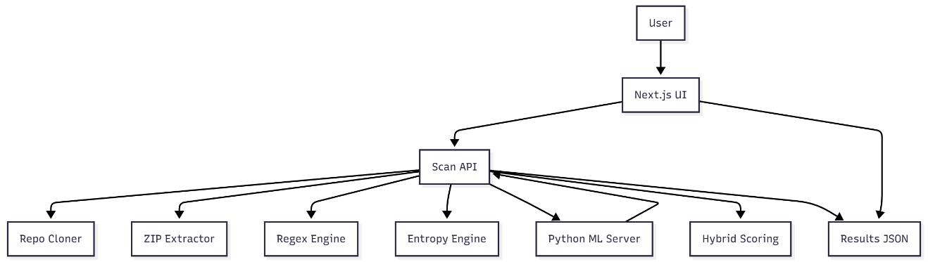

Repo cloning flow diagram
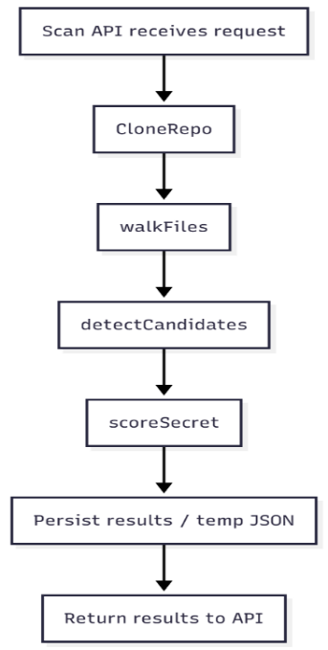
File walking flow diagram
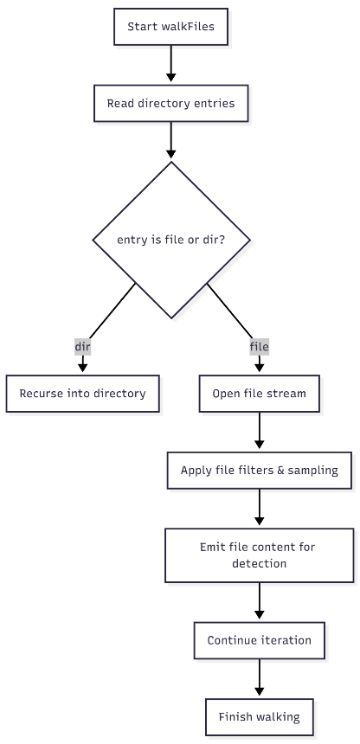
Regex + entropy detection flow
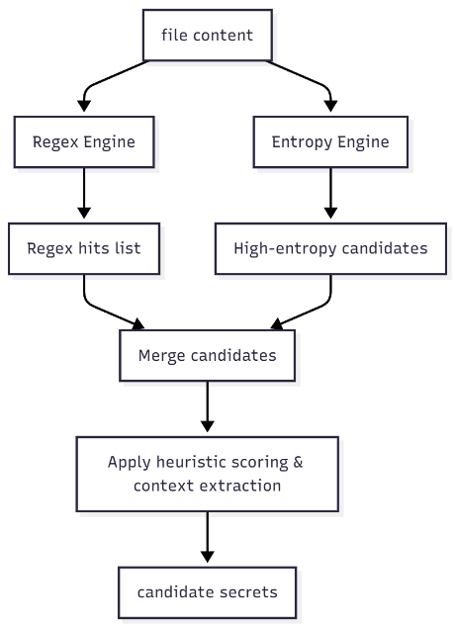

ML inference flow
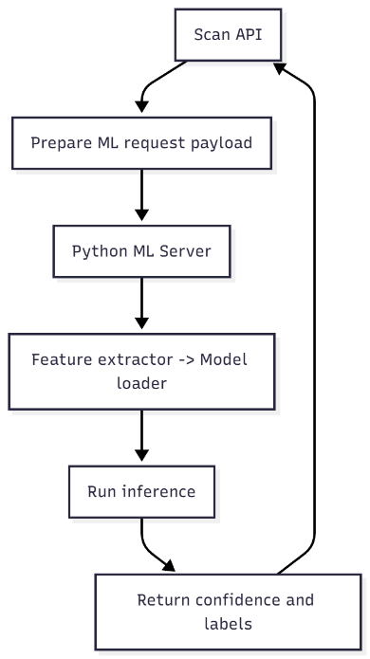

Security Analysis
Findings
- Regex-based detection reliably catches common secret formats (AWS/GitHub tokens).
- Entropy heuristics identify unknown/randomized tokens.
- ML inference significantly reduces false positives compared to heuristics alone.

Performance
- Shallow cloning and file sampling provide efficient scanning for large repositories.
- Binary & large-file skipping improves speed without major accuracy loss.
- ML inference introduces minimal overhead due to small feature vector size.

Security Considerations
- Sensitive repository content must be treated as untrusted data.
- All temporary workspaces must be isolated and cleaned after scanning.
- ML server should be placed behind firewall or authentication if deployed.
- Exported reports must be protected because they may contain masked but sensitive patterns.

Limitations
- Possible false positives with high-entropy random strings.
- ML generalization limited by training data.
- Secrets split across lines may be missed.

Lessons Learned
- Hybrid ML + heuristic models significantly improve practical precision.
- Repository scanning requires careful resource management.
- UI visualization greatly improves triage efficiency for security teams.

